OFFICIAL COORDINATION REQUEST FOR
NON-ROUTINE OPERATIONS AND MAINTENANCE

COORDINATION TITLE – 15-LGS-009 –Little Goose Unit 2 Digital Governor Repair
COORDINATION DATE – August 13, 2015 (FPOM Meeting).
PROJECT – Little Goose Dam
RESPONSE DATE – August 14, 2015.
Description of the problem –
Digital governors in Unit 2 have been upgraded, but commissioning is required to validate proper operation. This will require running units out of priority and outside of the 1% peak efficiency range.

This testing requirement is covered by the 2015 Fish Passage Plan, Appendix A, Paragraph 8.1.2. Testing is planned for Wednesday, August 17 through Friday, August 21 between the hours of 0700 and 1700. During the course of this testing, the unit will at times be turned off, operating at speed-no-load, and various loads. Total testing time is expected to be about 6-7 hours per day.

Unit 2 is currently out of service and preparations are occurring to bring it back in service, including model validation testing. During the testing, the unit will need to be operated a speed-no-load for approximately 3-4 hours per day, and above the 1% peak operating efficiency range for about 2 hours. If the Reservoir Control Center (RCC) raises the pool at Little Goose, Unit 2 will not be operated out of unit priority, since it is second in priority after Unit 1 and Unit 1 will be running during the testing. If water levels are low, Unit 1 will have to be shut down to test Unit 2, which violates unit priority.

Below is the text regarding this work from Appendix A of the 2015 Fish Passage Plan.

8.1.2. July 2015-2016: Digital Governor Replacement. Governor replacement will take place at Little Goose beginning July 2015, but may extend into 2016. This work will require performance testing and model validation testing. Thus running units out of FPP priority and outside 1%. See model validation testing paragraph. This contract work is subject to normal contracting and construction delays or issues.

Type of outage required – No outage required. Operation of turbine unit 1 outside of peak 1% efficiency is required for the successful completion of these tests. Note that when in service, turbine unit 1 is the highest priority unit during the fish passage season.

Impact on facility operation – Test operations will occur outside peak 1% operating efficiency.
Dates of impacts/repairs – Wednesday, August 17 through Friday, August 21 between the hours of 0700 and 1700.

Length of time for repairs – No repairs are necessary.

Expected impacts on fish passage – For adult fish, the impacts should be minimal. If pool levels are raised, Unit 1 will be providing attraction flow to the south ladder as expected, although testing may disrupt eddy patterns in the tailrace. If the pool is not raised, attraction to the south ladder may be reduced because Unit 1 will be out. Impacts will also be low since this testing will occur prior to peak runs of fall Chinook, steelhead, and coho. Juvenile fish may pass through Unit 1 (if operating) or over the spillway. Delays in juvenile fish downstream migration may occur if pool levels are increased. Impacts are expected to be minimal as tests are taking place during daylight hours and juvenile fish pass mainly at night.

Comments from agencies
Final results

Please email or call with questions or concerns.

Thank you,
Towns Burgess
Supervisory Fishery Biologist
Little Goose Lock and Dam
1001 Little Goose Dam Rd.
Dayton, WA 99328
509-399-2233 ext. 263
Email: oliver.t.burgess@usace.army.mil
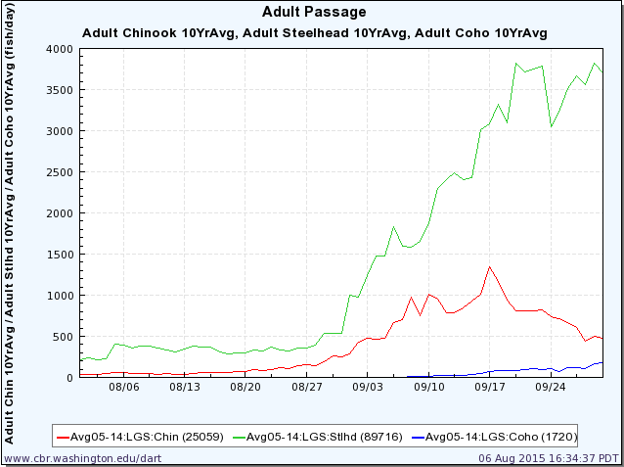
Work Window

